**Boston University**

**Electrical & Computer Engineering**

**EC463 Senior Design Project**

First Semester Report

Sol: Solar Power Plant with Remote Monitoring Application

Submitted to

Prof. Malay Mazumder

Boston University

8 St. Mary’s St Boston, 02215

(617) 353-0162

[mazumder@bu.edu](mailto:mazumder@bu.edu)

by

Team (15)

SOL

Team Members

Majid Al-Muhaideb [majidmuh@bu.edu](mailto:majidmuh@bu.edu)

Rahat Mahmood [rahat73@bu.edu](mailto:rahat73@bu.edu)

Alexa Wiencek [awiencek@bu.edu](mailto:awiencek@bu.edu)

Oluwaseun Angelo Soyannwo [seun@bu.edu](mailto:seun@bu.edu)

Steven Cheng [stcheng@bu.edu](mailto:stcheng@bu.edu)

Submitted: December 9, 2023

#### Table of Contents

Executive Summary 2

1.0 Introduction 3

2.0 Concept Development 4

3.0 System Description 5

4.0 First Semester Progress 7

5.0 Technical Plan 9

6.0 Budget Estimate 11

7.0 Attachments 12

7.1 Appendix 1 – Engineering Requirements 12

7.2 Appendix 2 – Gantt Chart 14

7.3 Appendix 3 – Other Appendices 16

# Executive Summary

Solar Power Plant with Remote Monitoring Application

Team Number 15 – SOL

Off-grid solar plants, solar power plants that work independently from the grid, are among the most promising solutions to rising alternative energy demand. These systems require an energy-storage element, usually a LiPo or SLA battery, and need additional safety considerations. Our client contracted us to work on a plant monitoring and control system that keeps track of key metrics in various parts of the plant, with an emphasis on battery safety. We have also been tasked with creating a remote-application that streamlines remote plant-monitoring. Our proposed technical approach involves the iteration of monitoring and control systems on a small-scale solar plant model. Our goal is to provide the client with a robust, flexible system that can be easily adapted to most off-grid configurations. Additionally, our client’s proposed system involves the use of Electric Double Layer Capacitors [EDLC] as an energy storage supplement for high-current loading, as well as Bifacial modules as our solar panels; both unique considerations introduce the need for a tailored plant-management system.

# Introduction

Environmental sustainability is among the most important and heavily researched topics in the 21st century. An overreliance on polluting sources of energy has placed our world on a destructive trajectory that threatens to eliminate swathes of nature and wildlife. The need for alternative power to replace non-renewable sources of energy encouraged the development of many different possible solutions, with solar among the leading technologies in sustainable power. Solar can be used in a variety of configurations in combination with the grid, from backup power to net-metering solutions. Off-grid configurations of solar-plants distinguish themselves from these variations by bypassing the grid connection, allowing users to create a self-reliant mini-grid disconnected from mains power. These configurations of plants allow users in rural or inaccessible areas to utilize sustainable power without the restrictions that accompany grid-connected power. These off-grid systems have several setbacks however and require additional engineering considerations, such as the need for batteries to store excess energy, as well as the safety systems that govern them and the plant. Our client, Professor Malay Mazumder, is working on a proposal to build such a plant on the roof-top of BU buildings. This proposal is in its infancy, and we have been contracted to assist with modeling the solar-plant and creating a management system that monitors and controls the plant.

As previously mentioned, off-grid plants require additional considerations to operate safely. Batteries are required to power loads during sun-absence periods, such as on cloudy days or during the evening, and must be constantly monitored in order to detect anomalous behavior that may cause damage. Furthermore, the condition of the solar panels must be constantly monitored in order to prevent reduced power or blackouts resulting from contamination or deterioration of the panels. These considerations in both safety and reliability introduce the need for a flexible and robust monitoring and control system that ensures the constant operation of the plant. Due to the project being in its early phases, we’ve also been tasked with creating a model that we will use as our benchmark for testing our plant management system. Additionally, our client requested that we integrate remote-monitoring considerations into our design, which we aim to achieve via a web-application that displays key-plant metrics.

Our goal is to deliver a robust, flexible management system that can be adapted for larger configurations of off-grid solar plants and can be remotely monitored, reducing the need for physical presence near the plant. Our solution will allow the client to develop his proposal and assist in ensuring the safety and reliability of the final product and provide him with insight into what pain points could cause delays in his proposal. Our approach in this project will be to build a bifacial solar module model, complete with a charge controller and battery, and fit our management system to this model. Additionally, we will research and implement an Electric Double Layer Capacitor energy storage layer to assist the plant battery system with abrupt high-current spikes that may cause battery degradation or damage.

# Concept Development

The goal of our client is to develop a means to reduce the carbon footprints of buildings at Boston University. This will be achieved through the installation of a solar-power plant. The power plant will consist of an array of bifacial solar panels in combination with a hybrid battery capacitor energy storage system. Each panel will have a reflector that changes position throughout the day, to maximize incident solar irradiance on the panel faces. The primary problem our client needs us to solve is ensuring the continued safety, particularly battery safety, of the solar-plant. Lithium-ion batteries, the battery type that the final system will use, are known to enter a process known as thermal runaway if they overheat, are overcharged, or are short circuited, causing fires or explosions. To prevent battery failure and other dangerour anomalies, our team is developing a monitoring and control system for the solar array. The monitoring system will have several sensors including measurements for voltage, current, and temperature. We have also received the request to design a remote application with a minimum range of 5000 ft that shows the data collected by the monitoring system. For this, a microcontroller connected to the monitoring system will send data to a web-based application to achieve both quick update times and sufficient operating distance.

It is important that proper operation of the plant can be verified remotely at any time. For this, our team is developing a remote application on a web server. This allows the state of the plant to be checked from a distance, as the server will continue to update its display of key system metrics. Using a web server makes accessing the remote application over a greater range away from the solar-plant itself possible. We chose this approach over an application based on bluetooth or similar wireless signals, as the functional range where the remote application would be accessible would be far below what we need to deliver.

The monitoring system being developed by the hardware side of our team is composed of individual sensors and a pico w. Putting together the monitoring system rather than opting for an off the shelf solution allows for greater customization in the design as well as ensures we are able to send monitored data to our remote application. Our client’s lab space already had a few products that measure some of the metrics we are monitoring, but these devices were not compatible with hardware from other brands and did not allow data to be exported (only printed to the led display). While this works perfectly fine for in-person monitoring, in order for the system to safely operate without direct supervision, it requires remote monitoring at all times. The sensors chosen for our system can easily connect to the pico w data in pins, allowing a straightforward flow from data collection to the remote display.

# System Description

Our system will consist of a solar power plant, monitoring system, and web application. The solar power plant will consist of an array of 6 bifacial solar panels connected in series with one another, an energy storage system, and a charge controller. Each bifacial panel is rated for 40W output power and will have a reflector module that sits underneath it and rotates throughout the day to maximize incident solar irradiation. The solar array will be connected to a hybrid energy system consisting of a set of batteries and supercapacitors. The hybrid system exists to respond to different changes in the needed output energy. When a quick spike of energy is needed, then the supercapacitors can be discharged, but when a more stable increase is needed, the batteries will discharge. We are currently planning to use some 300 farad capacitors with the Lithium polymer batteries that our client has ordered. The system will be connected to a charge controller which will ensure that the battery is operating within the specified current, voltage, and charge level limits.

Figure 1. System Overview

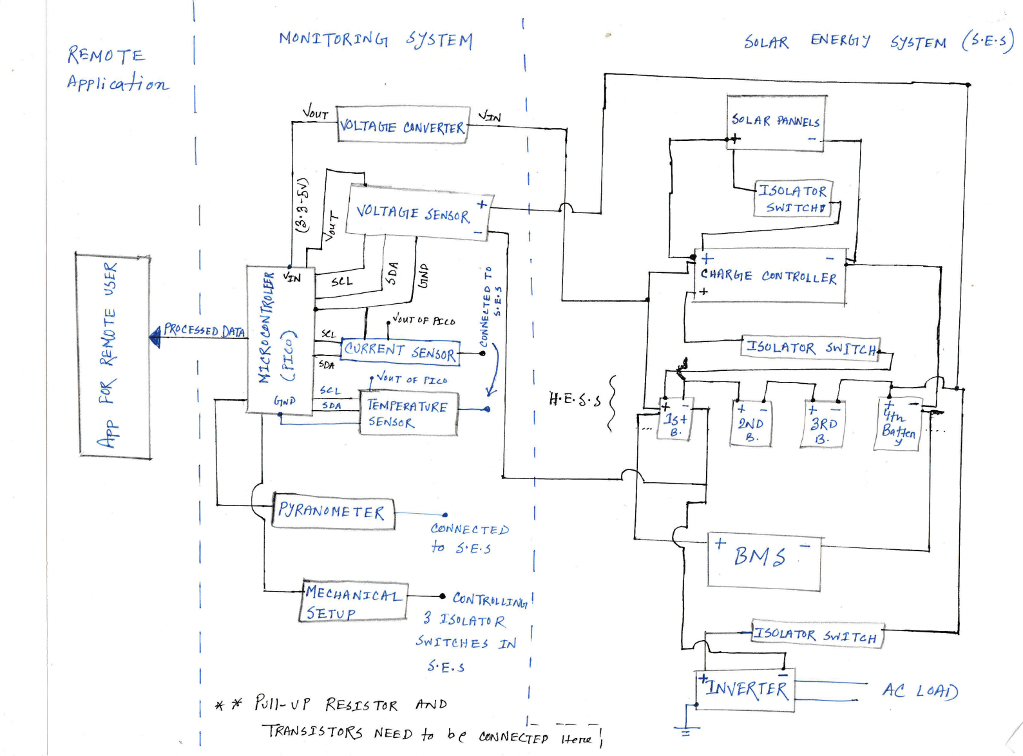

Our System will have three largely parallel sections: a remote application, a monitoring system, and a solar energy system. The monitoring system will be carefully connected to the solar plant and we will install the necessary safety components (i.e. relays and fuses.)

The monitoring system will consist of a Raspberry pi pico w and pin extension board connected to an array of sensors measuring power plant data (as of now we will be reading current, voltage, temperature and solar irradiance). The pico will make use of several python networking libraries (i.e. network and urequests ) to connect to the Internet and send sensor data to our database hosted on the Mongodb Cloud Atlas hosting service (via the services data API). We will use sensors to measure the voltage, current, temperature, and solar irradiation. The monitoring system will control isolator switches that isolate the batteries from the rest of the system during potentially dangerous operational levels. To read the values from these sensors we will use GPIO pins on the pico and Python libraries such as machine and sensors.

The web application will be a MERN (MongoDB, express.js, react, and node.js) stack application hosted on a cloud hosting platform such as digitalOcean or Heroku. In order to store the data from the pico we will be using a cluster on the MongoDB Cloud Atlas hosting platform to host our database. This way our microcontroller can directly send information to the database from any IP address (as we selected that setting on the online platform). The server side of the web application will be an express.js based server. It will handle any get, post, put, or head requests made from the front end (react) side. The express.js server will interact with our cloud hosted database. Express js is based on node.js is an asynchronous runtime that helps developers to build network applications. The client side will consist of a react client application made of react.js formatted html. The react client will make requests to the express.js web server using the axios javascript requests library. The web server will then send data back to the client to be rendered and displayed for our user.

The sensor data stored by our monitoring system needs to be used for trend analysis and anomaly detection. We will be using MongoDBs built-in chart embedding SDK in order to embed charts into our trend analysis page. Anomalies will be detected via a control loop on the pico that has set thresholds for normal operation. When these thresholds are passed, a notification will be sent to our users. As of right now we are planning to use Twillio web services for text messages in addition to the MicroPython umail library.

Figure 2. Software Overview

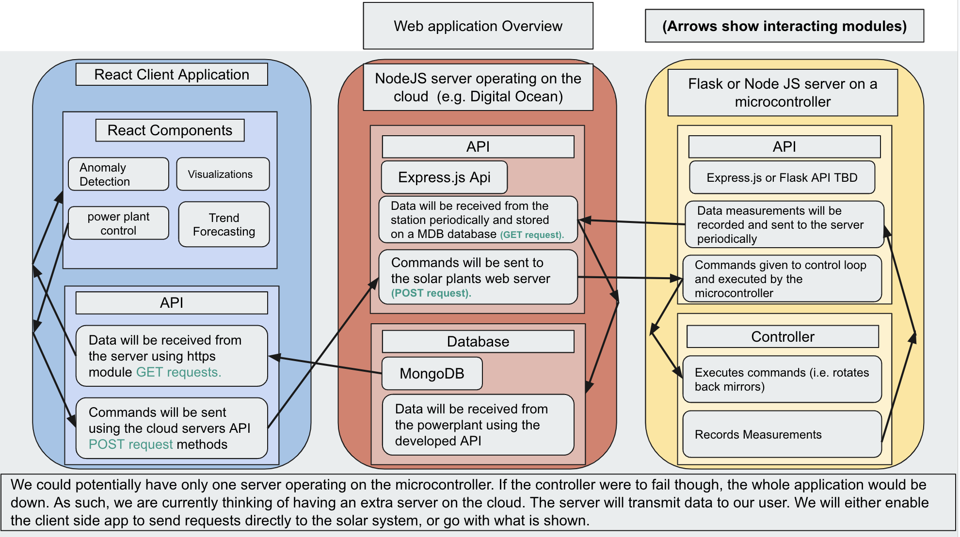

We will be using a react native client application that will be hosted on a cloud service provider and served to a user’s browser. This website will interact with a nodeJS server application running on the cloud which will handle logins and retrieving data from our cloud hosted MongoDB database. The MongoDB database will be updated by a Raspberry pi pico using the Cloud Atlas Data API.

Regarding the UI, our goal is to have as simple of a UI as possible. For our homepage We are going to have a central column that displays the data which our client wants. Next to that we will have a series of buttons that will allow our user to perform tasks such as adding additional solar arrays to his page and creating new solar Array instances.

Figure 3. UI

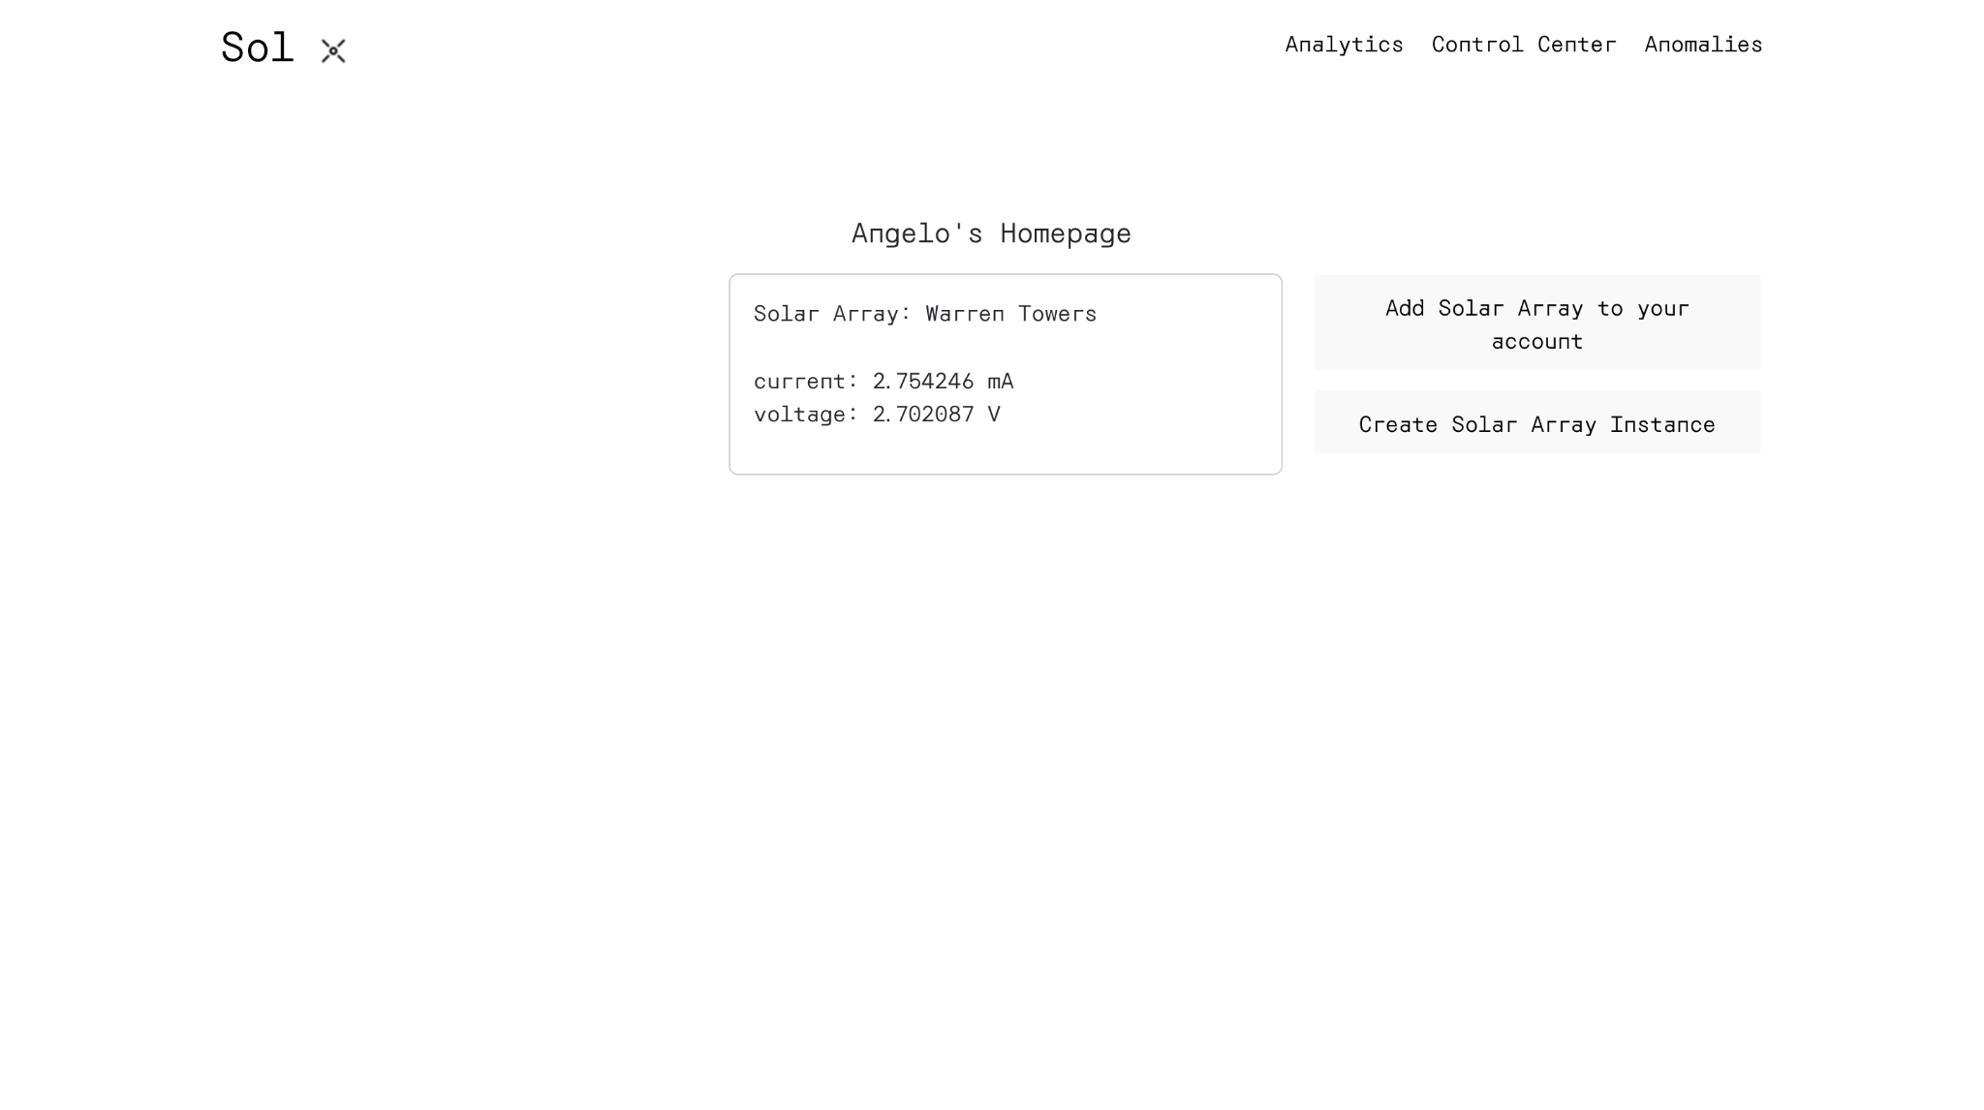

# First Semester Progress

During the first few weeks we developed an overview design concept that laid out the four main subsystems that would connect with each other. These were the physical plant, the monitoring system, the web application, and the control system. According to our project description, the physical plant was to be handled externally by our client such that we would focus only on the monitoring system through an embedded system using a Raspberry Pi Pico W, and a web application connecting to a server which the Pico W would also connect to. At this time, the control system was the only subsystem still abstractly defined, not strictly confined within a means such as a web application or physical system. We were unable to reach our client to ask for details and confirm our initial design during these first weeks.

During the Shark Tank, we gained valuable insight on additional considerations such as multiple temperature sensors in different locations of the plant, off-the-shelf solutions, and the obstacle of high power and current. During a meeting with our client, we learned that our project would encompass not only the monitoring and control system, but also the physical plant. Our client revealed that the solar plant had actually not been assembled, and that his current research team was working on its development. We decided that it was best to also include this collaborative responsibility in our overall project in order to ensure successful integration of all parts. The control component of our project was also defined to be strictly relating to the reflector system, not operation of the solar plant itself; the shutoff of the plant during anomalies was to be handled by the off-the-shelf charge controller.

The following week, our team discussed our new distribution of work. Alexa, Majid, and Rahat were to join the research team’s efforts in the solar plant assembly, while Angelo and Steven would begin development of the web application. Detailed below is the progress made on the hardware side and the software side.

**4.1 Hardware Progress:**

On the hardware side, we were split into two main workstreams, one focusing on creating a solar-plant model in collaboration with the client research team, and another centered around creating our management system prototype.

**Plant Management Workstream**

Three deliverables were worked on over the course of the semester. First, the monitoring system prototype, shown in Appendix 7.3. This prototype is the first iteration of our monitoring system, able to measure both voltage (12V) and current (1A) in various parts of the plant. The second deliverable is the control-system, also shown in Appendix 7.3 which uses data from its monitoring circuitry to adjust a stepper motor’s rotation that controls reflectors in the plant, which maximizes solar-irradiance.During the first iteration of this design, stepper motor was able to rotate total 68 steps clock-wise and 68 steps counter-clockwise based on the three time slots.

**Plant Model Workstream**

After extensive deliberations with our client and his team, we finalized the design for a small-scale solar power plant prototype which is the third deliverable. This system incorporates two solar panels configured in a series arrangement, mounted back-to-back. The panels are linked to a charge controller, a pivotal component in emulating a real-life, off-grid solar system. This setup centralizes the system, allowing for a precise simulation of real-world operational conditions. This model was demonstrated during our design review, and was a success. However, during our review, the battery was accidentally shorted and an audible hiss was heard, which was presumed to be caused by the hydrogen gas attempting to escape the enclosure due to the massive amount of current discharge resulting from the short. This incident brought into light the importance of incorporating a fuse for enhanced battery protection, as well as the need for a safety procedures document to ensure proper handling of energy-storage devices.

The schematics of the deliverable can be seen in Appendix 7.3

**4.2 Software Progress:**

Angelo has worked on developing a functioning web application front end with which users are able to create an account and add specific solar arrays to their account with solar array IDs, and monitor solar plant statuses. Angelo also worked on the back end such that the web page connects to our MongoDB database. During our prototype testing, we were able to demonstrate a functioning front and back end to display sensor values updated manually on our database. Throughout this time, Steven has also worked on the back end of the application, developing a dummy voltage and current reading function implemented in a data-post function all on the Pico W. In this way, the Pico acts as a localized server that communicates with the database, updating data incrementally with a set time. The dummy data reading functions will eventually be updated to incorporate our sensors. By the end of the semester, our team demonstrated the successful use of the web application, including creation of an account, login, adding and solar arrays to the account, and monitoring readings now automatically updated from the dummy sensor.

**4.3 Future Plans:**

In the last few weeks, we developed plans for next semester. On the software side, tasks include the implementation of the data analytics capabilities, and integration with the sensors. On the hardware side tasks include the incorporation of the proposed supercapacitors and LiPo batteries, and integration of the reflector system.

# Technical Plan

**5.1 Hardware:**

The client team arranged a number of tasks for us to work on outside the scope of our project. These tasks are meant to develop the project to a level where we can focus on creating a practical management system. The tasks are as follows :

**Task 1. Structure for solar reflectors**

A physical structure will be developed to hold reflectors, using TSLOT Aluminum and various small parts. The development process includes designing in SolidWorks, prototyping with a 3D printer, and conducting tests. The design will be evaluated for its capacity to hold reflectors weighing less than 500 grams and for its functionality in holding and rotating the stepper motor as per specifications.

**Task 2. Determine the torque for control system**

Nema 17 itself can provide maximum torque up to 0.5 Nm and to effectively gauge the torque required for maneuvering a solar panel reflector via a stepper motor and Raspberry Pi Pico, a strain gauge torque sensor shall be employed and calibrated, ideally attached to the motor's shaft. If necessary, incorporate an Analog-to-Digital Converter (ADC) like the HX711 to bridge the sensor's analog output with the Pico's digital input preference. Program the Pico for data acquisition from the sensor, ensuring GPIO pin setup and coding align with the task. Execute tests to record torque values during motor operation, and analyze this data to ascertain the needed torque range. Modify our setup or select an alternative motor based on these insights, consulting component datasheets and manuals for precise execution.

**Task 3. Integrating various features into control system**

A light sensor, such as the BH1750 shall be mounted externally on the black box housing of Raspberry Pi Pico to monitor light conditions to put the RPi into sleep mode for power savings and ensuring it's weatherproofed for outdoor use. Additionally, an anemometer shall be integrated with the Pico, selecting either a digital pulse output or an analog voltage output model based on our system's compatibility and ease of interfacing. Preferably use a digital anemometer for a more straightforward connection with the Pico. This configuration will be tested outside under various weather conditions.

**Task 4. Integrating Temperature sensor into monitoring system**

DS18B20 temperature sensor shall be integrated to monitor a LiPo4 battery's temperature as for long-term storage, keeping the battery in a temperature range of about -20°C to 25°C (-4°F to 77°F) is recommended. The Rpi shall be programmed to read and integrate temperature data with existing INA219 measurements. This system shall be tested and calibrated with the prototype solar plant for accurate monitoring, ensuring safe and reliable battery operation and remote data access.

**Task 5. Designing a reflector for solar panels.**

An easy and efficient reflector shall be designed for the solar panels to enhance its energy absorption and overall efficiency.. The design shall be focused on optimizing the shape and angle to maximize sunlight capture, using reflective materials that are durable and weather-resistant. It shall be ensured that the design is easily adjustable for optimal solar tracking throughout the year.

**Task 6 Building a Plant Model**

Due to the project being in its early stages, we do not have a plant on which to test our management system. As a result, we have been tasked with creating an approximate scaled model of the final system that we can design our project around. The plant uses all the necessary architecture for an off-grid solar system, including a charge-controller, an energy storage element and a BMS.

**5.2 Software:**

**Task 1. Integrate MongoDB Chart SDK into react application**

Display chart data for the logged in user’s solar arrays to the trend analysis page.

**Task 2. Add trend Analysis capabilities**

Our client wants to be able to monitor and forecast certain performance metrics based on past data. We will need to integrate these capabilities into the web application.

**Task 3. Add Notifications**

We must be able to notify our users of anomalous behavior through text and email. We will integrate this into the monitoring system using the python umail library and tentatively twilio web services.

**Task 4. User feedback and iteration**

Our users will test the product and give us feedback to iterate and improve.

# Budget Estimate

| **Item** | **Description** | **Cost** |
| --- | --- | --- |
| 1 | Solar Modules | $75.00 |
| 2 | Charge Controller | $12.00 |
| 3 | Batteries | $40.00 |
| 4 | BMS Shunt | $90.00 |
| 5 | Fuse Holders | $10.00 |
| 6 | Crimp Terminals | $18.00 |
| 7 | SLA Charger | $12.00 |
| 8 | Wires | $20.00 |
| 9 | Connectors | $15.00 |
| 10 | Raspberry Pi | $7.00 |
| 11 | INA219 | $3.00 |
| 12 | RTC-DS3231 | $3.50 |
| 13 | A4988 Stepper | $7.00 |
| 14 | Nema 17 stepper motor | $14.00 |
|  | Total | $326.50 |

Since our client has been working on this proposal before contracting our team, we were given access to multiple key items that assist us in the creation of the solar model, which are highlighted in gray. The monitoring and control elements, however, are new to this project and must be sourced either via our client or through the senior design budget. Additionally, due to the iterative nature of our project, this budget does not encompass total expenditures, and is expected to grow. The solar panels, which constitute the majority of the cost, were given to us by the client, which means our future increases to the budget shouldn’t cause any planning issues.

# Attachments

# Appendix 1 – Engineering Requirements

Team #15 Team Name: SOL

Project Name: Solar Power Plant with Remote Monitoring Application

| **Requirement** | **Value, range, tolerance, units** |
| --- | --- |
| Data storage | 100mb of time series data storage |
| Power | 40-80W |
| Current | 2-5 Amps |
| Monitoring System | Capable of measuring up to 26V, 2A, and 45° C. Able to successfully connect and send data values to the web server. |
| Control System | Able to move reflectors through the desired range of angles. Provides at least 0.5 Nm of torque. |
| Reflectors | Can reflect additional light onto the solar panels to increase energy absorption and overall efficiency. Must have position adjusted throughout the course of the day in response to the position of the sun. |
| Number of concurrent users on the web application | 10-15 |
| Number of creatable Solar Array instances in our database | 100+ |
| Trend Analysis | Time series data for the operation of the solar plant must be present in the front end application as charts. |
| Notifications | The system must notify users through at least email of anomalous behavior. |
| Lithium polymer battery and supercapacitor hybrid energy storage | The system must use a hybrid lithium polymer and super capacitor configuration to store energy. |
| Safety | The solar plant will make use of a battery monitoring system (the one provided with our client’s battery), as well as 3A fuses in order to meet our client’s safety standards. |

# Appendix 2 – Gantt Chart

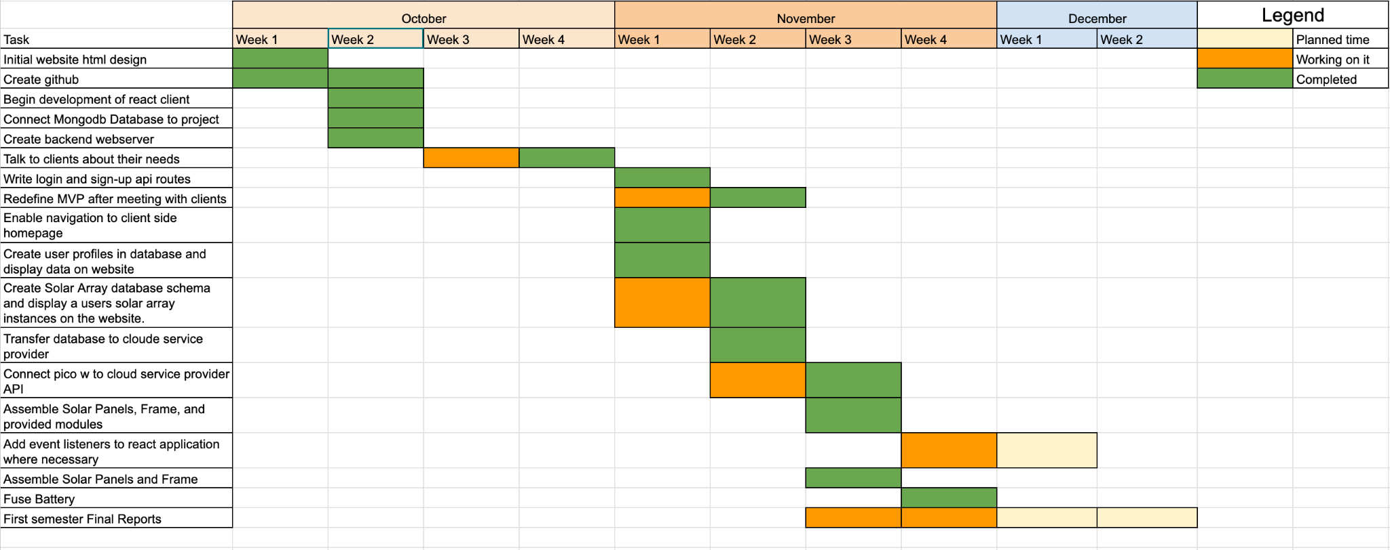

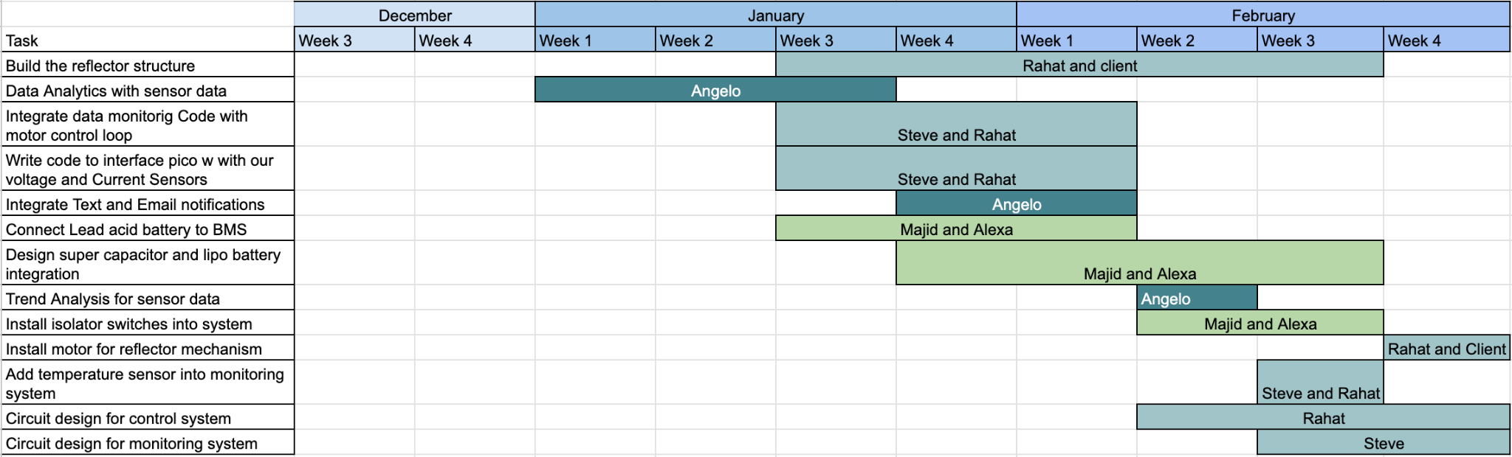

# Appendix 3 – Other Appendices

**Monitoring system :**

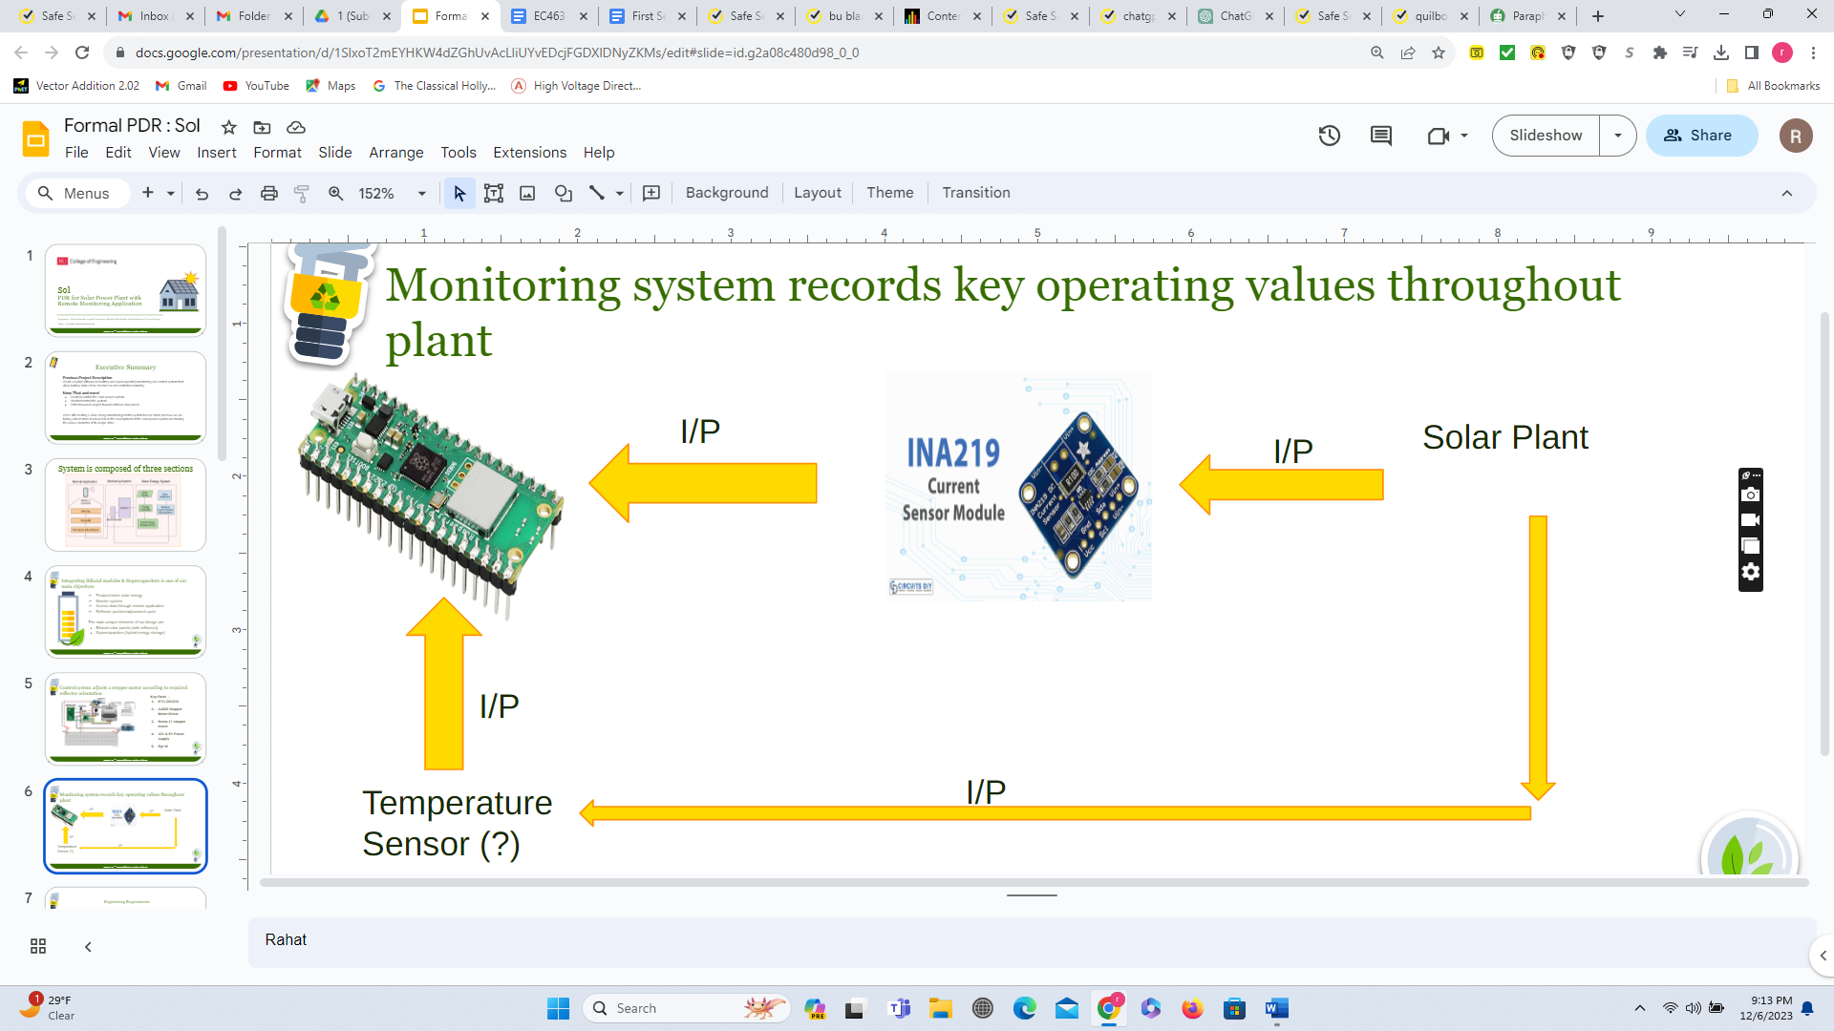

Figure : Block Diagram of Monitoring system

**INA219 Sensor :** The INA219 is a compact, I2C-compatible current shunt and power monitor. Key features include bi-directional current sensing, a voltage range from 0V to 26V, current range up to 3.2A, programmable calibration for varied current levels, and high accuracy in measurements. It supports standard and fast-mode I2C communications, making it easily integrable with microcontrollers like Raspberry Pi. This sensor is ideal for applications in energy monitoring, battery management, and power supply systems, where precise current and power measurement is essential.

**Control System :**

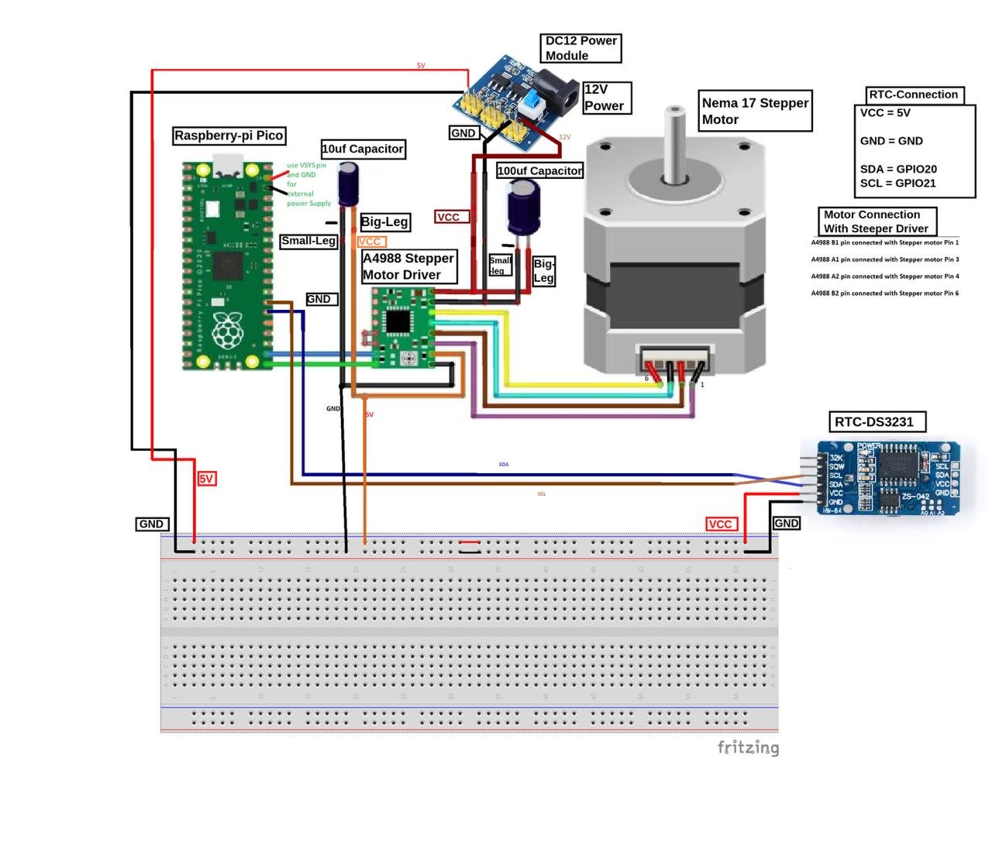

Figure : Wiring Diagram of the control system

**RTC-DS3231**: A precision Real Time Clock module with temperature compensation, I2C communication, and a backup battery feature for accurate timekeeping.

**A4988 Stepper Motor Driver:** A driver module for bipolar stepper motors, supporting up to 2A per coil and variable step sizes for precise motor control.

**Nema 17 Stepper Motor:** A standard-sized stepper motor known for its precision and high torque, commonly used in 3D printers and CNC machines.

**Raspberry Pi Pico W:** A microcontroller with Wi-Fi, based on the RP2040 chip, featuring dual-core processing, 264KB SRAM, and 2MB Flash memory, ideal for various applications and projects.

**12V & 5V Power Supply:** 12V power supply has been used for stepper motor driver and 5V for RTC module.

**Solar Power Plant:**

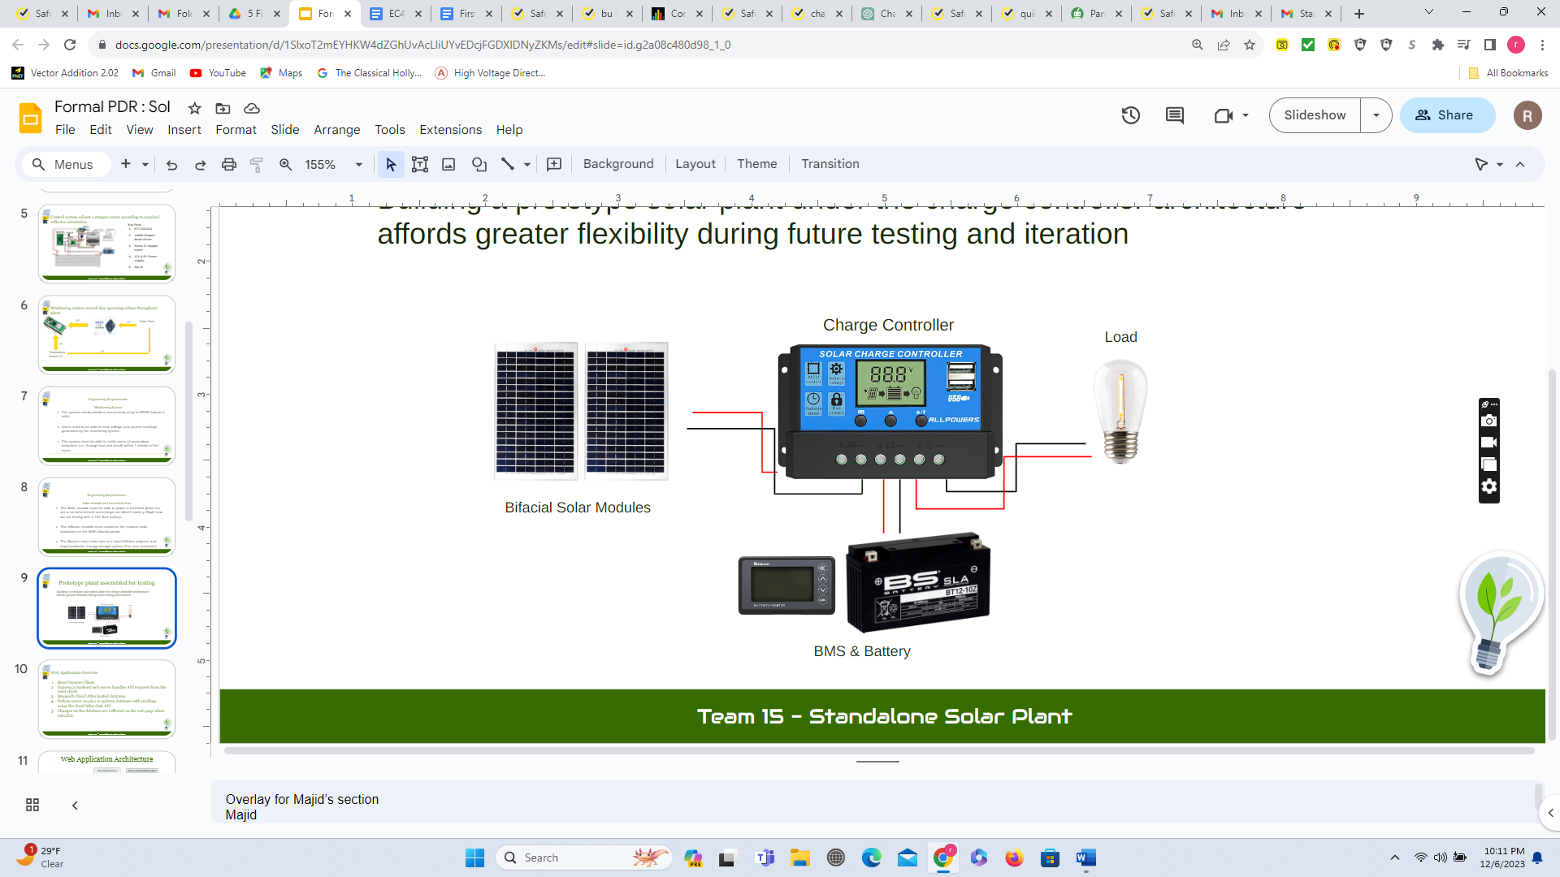

Figure : Block diagram of the Solar Power Plant

**Bifacial Solar Panel (48V, 0.65A):** Generates power through exposure to light. Model uses two single-faced photovoltaic panels wired in series, each generating 20W at peak output, for a total of 40W.

**Charge Controller:** Manages voltage and current from solar panels to protect the battery from overcharging or the load from drawing excess current.

**12V SLA Battery:** Features a reliable and low-maintenance Sealed Lead-Acid battery used for energy storage in solar systems.

**BMS with Monitoring Display:** Monitors and manages the battery's condition, ensuring safety and efficiency, equipped with a user-friendly display.

**Small Light Bulb (Electrical Load):** Demonstrates the practical use of stored solar energy for everyday electrical applications.

Figure 1. System Overview



Figure 2. Software Overview



Figure 3. UI



**Team Information Sheet:**

**Rahat Mahmood** is a senior undergraduate student at Boston University, majoring in Electrical Engineering. His industry experience includes designing Single Line Diagrams (SLD) and Three Line Diagrams (TLD) for 5-10 MW grid solar interconnection projects and involved in extracting and analyzing data from relevant studies for those projects. He has also been involved in conducting very high-level relay settings for transformers and Arc Flash calculations for renewable energy firms and utilities. Rahat is an active member of the IEEE Power and Energy Society and is committed to furthering his expertise in this area. He can be contacted at 857-389-5964 or [rahat73@bu.edu](mailto:rahat73@bu.edu)

**Steven Cheng** is a senior Electrical Engineering student at Boston University. He has worked as a research assistant for Professor Joshua Semeter on data analysis of ionospheric data. Currently, he is an intern with Neural Dynamics Technologies as an embedded engineer. After graduation, Steven plans on moving to New London, Connecticut to work as a Systems Engineer for propulsion systems at General Dynamics Electric Boat. He can be contacted at [stcheng@bu.edu](mailto:stcheng@bu.edu) or 201-783-7390.

**Alexa Wiencek** is a senior undergraduate student majoring in Electrical Engineering at Boston University. They have worked as a Learning Assistant for Engineering Mechanics, including giving a guest lecture for the course, as well as having been a coordinator of the Artemis Project in the summer of 2022. They have worked for Boston University’s Electronics Design Facility as a student technician. Currently, they are the acting recording secretary for the Kappa Sigma chapter of IEEE-HKN. After completing their undergraduate degree, Alexa will continue their studies, working towards a MS in Electrical and Computer Engineering. They can be contacted at [awiencek@bu.edu](mailto:awiencek@bu.edu) or 646-531-2139.

**Angelo Soyannwo** is an undergraduate student at Boston University studying electrical and electronics engineering. He has previous experience working as an intern at James Cubitt architects as well as First Class Group dLimited. He has plans to incorporate his own company after graduation and is currently on track to complete his degree in Fall of 2024. He can be contacted at [seun@bu.edu](mailto:seun@bu.edu) or 929-888-3930.

**Majid Almuhaideb** is a senior undergraduate student at Boston University, majoring in Electrical Engineering. He previously worked as a Teaching Assistant for Electric Circuits. He previously worked as an intern in management consulting firm McKinsey & Co, and plans to return after graduation. Majid is set to graduate in Fall of 2024. He can be contacted at [majidmuh@bu.edu](mailto:majidmuh@bu.edu)

This team was assembled to complete the senior design project described in this progress report. We will spend two semesters researching and designing the monitoring and control system requested by our client

**References:**

Abdelhady, Suzan & Borello, D. & Tortora, Eileen. (2014). Design of a small scale stand-alone solar thermal co-generation plant for an isolated region in Egypt. Energy Conversion and Management. 88. 872-882. 10.1016/j.enconman.2014.08.066.

Ang, Benjamin, et al. *EC464 Capstone Senior Design Project User’s Manual Sol-R Solar Panel Installation*, Boston University Electrical &amp; Computer Engineering, 1 May 2023.

Capone, Zachary, et al. *EC464 Capstone Senior Design Project User’s Manual ClearSol*, Boston University Electrical &amp; Computer Engineering, 25 Mar. 2022.

Laura Cozzi et al, “For the first time in decades, the number of people without access to electricity is set to increase in 2022”, IEA.com, published on July 17th 2014, accessed on 1st October 2023,

https://www.iea.org/commentaries/for-the-first-time-in-decades-the-number-of-people-without-access-to-electricity-is-set-to-increase-in-2022#:~:text=According%20to%20the%20latest%20IEA,the%20numbers%2020%20years%20ago.

Pioneer Electric Cooperative inc, “Line Extension Cost”, pioneerelectric.coop, accessed on 1st October 2023, https://pioneerelectric.coop/my-account/help/line-extension-cost/.

Samantha M. Kelly, “Lithium-ion battery fires are happening more often. Here's how to prevent them”, last updated on 9th March 2023, accessed on 7th October 2023, https://www.kcra.com/article/lithium-ion-battery-fires-how-to-prevent-them/43266541#.

Shahzad, Umair. (2015). The Need For Renewable Energy Sources.

"Raspberry Pi," Raspberry Pi Foundation, [Online]. Available: <https://www.raspberrypi.com/for-home/.>[Accessed: September 21, 2023].